Below are frequently asked questions with links to the answers

Webex Teams FAQ

* **What is Cisco Webex Teams? What happened to Cisco Spark?**

**Personalization**

* **What are the file requirements for my profile picture?**
* **Where do I change my theme color?**
* **Am I able to choose what notifications I receive?**
* **Where do I change my status to show I’m busy and don’t want to be disturbed?**

**Messaging**

* **What are the messaging capabilities in the Webex Teams app?**

* **Are there size limitations to the messages you can send?**
* **What is a thread?**
* **How do I share a file?**
* **Can I see all the files shared in a space?**
* **How do I use the whiteboard feature?**

**Spaces**

* **What is a space and how can I work within one?**
* **Why would I create a space with one person?**
* **What is a Team Space?**
* **How do I initiate a meeting within a Space?**
* **What is a moderator and what do they do?**
* **If I invite someone to a space that is not part of our organization, what sort of privileges do they hold?**
* **How do I identify external participants within a space?**

**Meetings**

* **What are the meeting capabilities in the Webex Teams app?**
* **How do I schedule a meeting with everyone in a space for a certain date and time?**
* **How do I view my upcoming meetings?**

**Connect with Devices**

* **How do I automatically connect to a Webex Device?**
* **How do I manually find and connect to a Webex Device?**
* **What features are available when connecting to a Webex Device?**

**Accessibility**

* **What accessibility features are available?**

## Q: What is Cisco Webex Teams? What happened to Cisco Spark?

A: Cisco Spark became Cisco Webex Teams in May 2018. Webex Teams is an app for continuous teamwork with video meetings, messaging, file sharing and white boarding.

## Q: What are the file requirements for my profile picture?

A: You can use lots of common graphic formats for your picture: .jpg, .png, .gif, or .bmp. Or use the camera on your phone to take a quick selfie. The file has to be under 10 MB, though and ideally a square image between 200x200 pixels and 1000x1000 pixels. Webex Teams resizes your file to use in Webex Teams.

If your picture doesn't change for you, it could be the file size. Or, your picture may be set through your organizations directory and you'll need to contact your administrator to change it. If other people don't see your changed picture, it's probably down to the local caching on their apps, the change can take up to four hours to show for other users.

You add a profile pic by clicking on your initials. Once you add a profile picture you can only replace it with another picture.

## Q: Where do I change my theme color?

A: Click your [**profile picture**](https://collaborationhelp.cisco.com/article/m67xht), select **Settings** > **Appearance**, choose your preferred theme, then click **Save**. You'll then be prompted to restart Webex Teams to apply the changes.

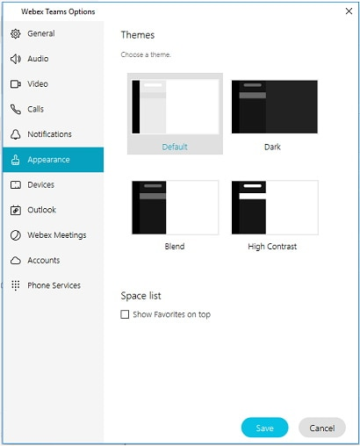

## Q: Am I able to choose what notifications I receive?

A: Yes, Webex Teams allows you to set notifications in two ways - for All Spaces or for Certain Spaces. These settings work together so that you don't miss anything and that you can keep up-to-date with what's happening.

* *Set Notifications for All Spaces* - Click your **profile picture**, then select **Settings** > **Notifications** and set your preferences
* *Set Notification for Certain Spaces* - In the space, click information  , select **Notifications**, then choose a setting, and click **Save** to set your preferences.

Webex Teams suppresses notifications for incoming messages or calls when you're sharing your screen or application while on a call or on a meeting.

## Q: Where do I change my status to show I’m busy and don’t want to be disturbed?

A: If you need some quiet time to work without getting any Cisco Webex Teams message or call notifications, you can set your status to Do Not Disturb (DND). Your status is also updated so that other users can see that you don't want to be disturbed. You'll still see your unread indicators, so you can still see the messages you haven't viewed. People can still send you messages.

* Click your profile picture, click **Status**, and choose how long you don't want to be disturbed.

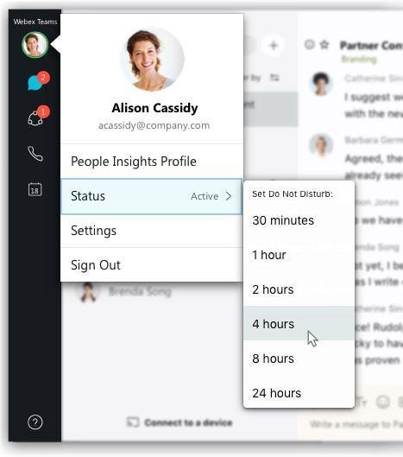

* Click **Off** to change your status back to **Active** so people know that they can contact you again.

## Q: What are the messaging capabilities in the Webex Teams app?

A: New messages will have a blue dot next to them, just click one to read them. You can send messages, share files, pictures, videos, and even gifs in Webex Teams. You can add emojis or use @mentions to get someone’s attention in a space. @mentions help people notice urgent or important messages. You can reply to a thread to keep conversations organized in a group space. You can flag messages that you think are important to follow up on them later. Simply click on a shared File to preview it or download the file to your device. The Webex Teams app keeps a list of all the content shared in a space, so you’ll never lose track of it.

## Q: Are there size limitations to the messages you can send?

A: Yes.

| **Feature** | **Maximum Limit** |
| --- | --- |
| Auto play GIF | 2MB |
| File size | 2GB |
| Message size per post | 5400 characters |
| Number of files you can add to a single message. | 10 files |

## Q: What is a Thread?

A: When you're working in a busy space, it's sometimes difficult to keep track of people's comments. To make it easier to follow specific conversations, you can reply to someone's message simply start a new message thread or reply to one that has already started.

* Hover over the message or the file and click **Start a thread**.
* After you create the thread, you or anyone else in the space can add a reply to that thread, click .
* When somebody replies to a thread, you'll see a notification in the space to highlight the new replies.

## Q: How do I share a file?

A: You can share most types of files except for .tif files, and the largest file size that you can upload to a space is 2 GB. You can also preview documents without downloading them first if they're no more than 50 pages and less than 100 MB in size, and one of these file types: .doc, .docx, .gif, .jpeg, .pdf, .png, .ppt, .pptx, .xls, and .xlsx

When you add animated GIFs, they'll play automatically in the app if you keep their file size to under 2 MB.

* Drag and drop the file into the message area, click **Attachment**  to select a file, or click **Screen capture**  to select a part of your screen to capture. Then, press **Enter** to send the file.

## Q: Can I see all the files shared in a space?

A: Yes, when people share files in a space, you can view or download them as they're posted. Or, you can see a list of recently shared files without scrolling through the messages.

* *Preview*—Click the file to get a quick preview. You can also download the file from here.
* *Download*—Hover over the file in the space, click **Download** , then click **Show in folder**  to see the file download location.
  + You can choose the default download folder. Go to **Settings** > **General** > **Default file download location** and click **Change**. Then, select a new download location and click **Save**.
* *See All Files*—Go to the activity menu  and click **Files**  .

## Q: How do I use the Whiteboard feature?

A: You can create whiteboards in a space, anyone in the space can then choose to view or edit them. You can also use whiteboards in a meeting, you can create or open an existing whiteboard, and then share it on the call so that everyone can view it.

* Select the space, click the activity menu , choose **Whiteboard** , and then select **New whiteboard**.
* You can select the following:
  + Color  changes the marker color.
  + Eraser  turns the marker into an eraser to remove edits or click eraser  again to select **Clear all** and remove all edits. You can click undo  to restore the edits you just cleared.
  + Stickies  creates and adds stickies. You can add text, change the color, and move the stickies around your whiteboard.
  + Undo  removes your last edit. You can continue to click undo and remove each edit until you return to the last saved whiteboard.
  + On a shared whiteboard, if someone selects **Clear all**, undo is unavailable. However, if you select **Clear all** and nobody else edits the whiteboard, you can click undo  to restore the edits.
  + There's no limit to the size of your whiteboard. Use the arrow keys on your keyboard to move around the whiteboard. You can use a mouse or a touchpad to zoom in or out on the whiteboard.

## Q: What is a space and how can I work within one?

A: All of your work takes place within spaces in the Cisco Webex teams app. Inside a space, you can send messages, make calls, have video meetings, share files, and whiteboard. You can choose from three types of spaces: people, spaces, and team spaces, depending on why you need to chat.

Spaces work well for a group of people working on a specific topic. You come together to handle this thing (which might be something quick or long term), but the focus is more narrow and specific. If your intention changes and that project outgrows its original purpose, you can simply move the space into a team, and it becomes a team space.

## Q: Why would I create a space with one person?

A: The “Contact a Person” option will allow you a space for a persistent chat directly with one individual. The conversation will remain between the two of you and you cannot add other people to the conversation at a later time.

## Q: What is a Team Space?

A: Teams help you keep everything organized by putting multiple spaces under a common theme. Teams are great for a consistent group of people who are going to be working on something for a long time. That something might be complicated and involve many activities or could be subprojects happening at the same time.

Every team has at least one team space, General that you’re automatically added to when you’re added to the team. As a team member, you can view and join all spaces in the team, and you can also create team spaces for others to join.

## Q: How do I initiate a meeting within a Space?

A: If you’re working with at least 3 people in a Space, you can start an instant meeting directly from that space. The number of people who can join the meeting varies for each space, depending on the Webex Teams licenses of people in that space.

From your space, go to the activity menu   and choose Call or Meet . The meeting starts instantly, and everyone in the space sees a Join button in their meeting list and in their spaces list in the Webex Teams app. They also get a meeting notification on their computer or mobile phone.

## Q: What is a moderator and what do they do?

A: In Cisco Webex Teams, if you're a moderator in a space or team, you can add others, remove people, edit, and assign others as moderators. Keep in mind that even if you've created the space, you're not a moderator unless you chose to moderate the space from the space settings.

* *Add a person as a moderator to space* - Select the space, click the activity menu  and choose **People** . Then right-click on the person's name and select **Assign as Moderator**.
* *Add as Moderator to Team* - Go to your Teams  and choose the team. Select  Add Team Moderator and enter the person's name.
* If you want to remove someone as a moderator, right-click on the person's name and select **Remove as Moderator.**

## Q: If I invite someone to a Space that is not a part of our organization, what sort of privileges do they hold?

A: As an external participant in a space, they can participate in everything going on within that space they were invited to. They will not be able to see or join other spaces.

## Q: How do I identify external participants within a space?

A: You'll see some areas in those spaces highlighted, like the border, message background, and icon in the message area and their email addresses. It’s best practice to identify spaces that include external participants within the team name (Ex. *External* Cisco Collaboration Team).

## Q: What are the meeting capabilities in the Webex Teams app?

## A: Webex Teams gives you several options for hosting meetings, but to simplify things, you can either schedule a meeting for later or start a meeting right away. When you schedule a meeting from your calendar, you can add an agenda or attach files. If your meeting is associated with a Webex Teams space, you can share files and messages about the meeting directly in the space. When it’s time for your scheduled meeting or call to start, just select Join. Inside of the meeting you can share your screen, specific applications or videos with everyone. Create Whiteboards in the app for people to edit or share one that someone has already added to the space. Continue the discussion after the meeting by adding more information to the space. Post files or presentations that you shared during the meeting to the space.

## Q: How do I schedule a meeting with everyone in a Space for a certain date and time?

A: Use Webex Teams to create calendar invites that you can send to everyone in the space to tell them about the meeting and how to join.

To Schedule the meeting, go to the activity menu   and select Schedule   followed by Schedule a meeting. This will create an Outlook meeting invite with everyone in the space and meeting information included. All you must do now is adjust the date and time.

## Q: How Do View My Upcoming Meetings?

A: You can view details about your upcoming meetings in your meetings list. When it's time for a meeting to start, you can join it from the meetings list, too. Go to **Meetings**  and find the meeting in the meetings list.

## Q: How do I automatically connect to a Webex Device?

A: You can use the Cisco Webex Teams app to automatically connect to a nearby Cisco Webex room or desk device and a Cisco Webex board.

* Go to your profile picture and click Settings > Devices.
* Check **Use ultrasound** and **Connect to nearest device automatically**:

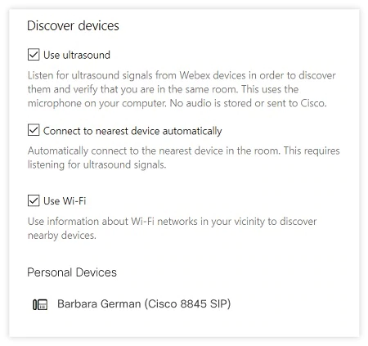

You automatically connect to the nearest device in the room.

## Q: How do I manually find and connect to a Webex Device?

A: You can search for available Webex devices using ultrasound or your Wi-Fi network.

* Select **Connect to a device** to automatically search for nearby devices using either ultrasound or Wi-Fi.
* If you don't see the device that you want in the list, select **Search for a device** and enter the name of the device you want to use.

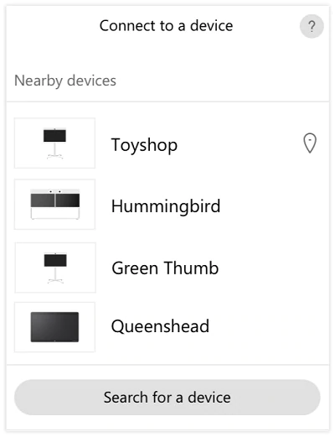

## Q: What features are available when connecting to a Webex Device?

A: When you connect to a device you can control it using the Webex Teams app and use it in the following ways:

* Share your screen locally.
* Answer a call.
* Start a meeting in a Webex Teams space.

## Q: What accessibility features are available?

A: Webex Teams provides basic support for **Screen Readers**, **Keyboard Navigation**, and **High Contrast**. To find out more information, click [here](https://help.webex.com/en-us/0ix72j/Accessibility-Support-for-Cisco-Webex-Teams#id_85525).