Frequently Asked Questions

I'm switching from Skype for Business to Teams. What do I need to know?
What's the difference between a team and a channel?
What does it mean to be @mentioned?
How do I create a new team?
How do I add a team member?
How do I start a private chat?
Can I delete an old chat?
How do I remove someone from a chat?
How do I add guests to a team?
How do I set guest permissions?
What are apps in Teams and why would I use them?
How do I configure an app for a team or my personal use?
How do I block a bot?
Can I use Planner in Teams?
Can I recover a deleted team or channel?

Q: I'm switching from Skype for Business to Teams. What do I need to know?
A: You'll find a lot of familiar features as you make the switch from Skype for Business to Microsoft Teams—plus a few new things we hope you'll like!

Task | Skype for Business | Microsoft Teams
Chat (IM)
Start a chat with individuals or groups
Turn a chat into a call
Share a file with people in a chat
Share a file with offline participants
Add emoji
Add GIFs and memes
Threaded and persistent conversations
Search for files, content, and people
Meetings
Schedule a meeting from Outlook
Share desktop or app
In-meeting access to chat and files
Persistent chat before, during, and after the meeting
@mention people and like conversations
Calls
Make, forward, and transfer calls
Mobile
Chat, call, and meet from your mobile device

Plus Teams offers...

- Teams and channels for tracking projects, conversations, files, and meetings all in one place.
- Office app integration.
- Customizable apps and bots.
- @mentions to get someone's attention.

Back to top

Q: What's the difference between a team and a channel?
A: A team is a group of people gathered to get something big done in your organization. Sometimes it’s your whole organization.

Teams are made up of channels, which are the conversations you have with your teammates. Each channel is dedicated to a specific topic, department, or project.
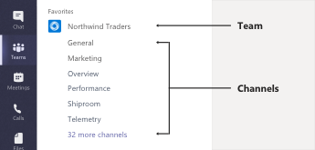

For example, the Northwind Traders team has General, Marketing, Overview, and 35 more channels. All the conversations, meetings, files, and apps in the Marketing channel have to do with marketing, and everything in this channel is visible to everyone on the Northwind Traders team.

Channels are where the work actually gets done—where text, audio, and video conversations open to the whole team happen, where files are shared, and where apps are added.

While channel conversations are public, chats are just between you and someone else (or a group of people). Think of them like instant messages in Skype for Business or other messaging apps.

Back to top

Q: What does it mean to be @mentioned?
A: An @mention is like a gentle tap on your shoulder—a way to get your attention in a channel conversation or chat.

When someone @mentions you, you get a notification in your Activity feed, and you also see a number next to the channel or chat you were @mentioned in. Click the notification to go directly to the point in the conversation where they mentioned you.

If you ever feel a little overwhelmed by all your @mentions, you can always filter your Activity feed to help sort them out.

To @mention someone, just type @ in the compose box and select their name from the menu that appears.
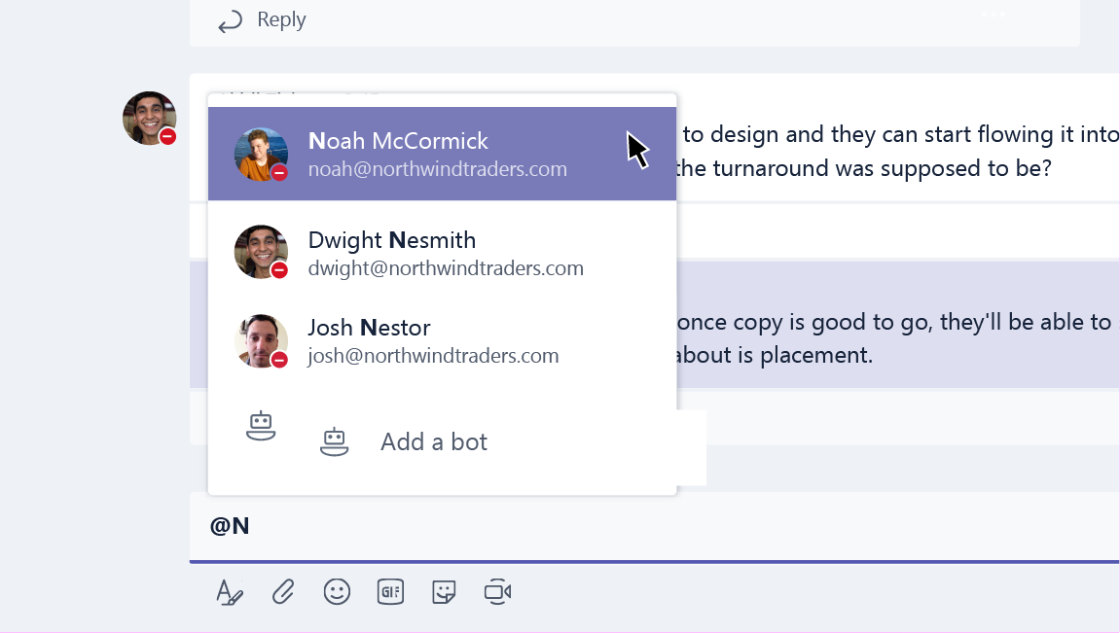

Back to top
Q: How do I create a new team?
A: Click Teams on the left side of the app, then click Add team at the bottom of your teams list. Go to the first tile in the Suggested teams view and click Create a team.

From there, you can invite people or even entire contact groups (aka "distribution lists") to join your team.

Now that you have a new team, why not add some new channels for specific conversation topics? Or even invite guests from outside your organization to help with a project?

Back to top

Q: How do I add a team member?
A: If you're a team owner, go to the team name and click More options > Add members.

This is also where you can invite guests from outside your organization to join your team.

Add multiple people by typing the name of a contact group (aka a "distribution list"), security group, or Office 365 group.

Back to top

Q: How do I start a private chat?
A: To send a private message, first click New chat at the top of the app to start a new conversation. Type the name of the person or people you want to chat with in the To field. Then, compose your message and click Send .

Need to add someone to a chat that's already going on? Just click Add people in the upper-right corner of the chat.

Back to top

Q: Can I delete an old chat?
A: To delete a chat message, press and hold the message and select the delete option. To delete a message in a channel, tap More options and select the delete option.

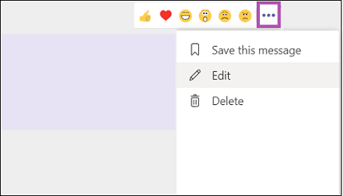

Back to top

Q: How do I remove someone from a group chat?
A: Hover on the number of participants and then hover on the person's name you want to remove. Select the X and confirm you want to remove the participant from chat. An update in the chat will inform everyone that you've removed the person.

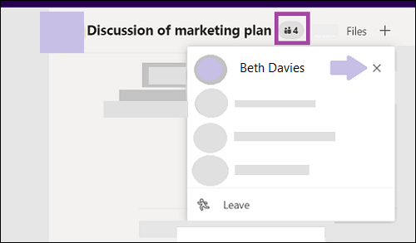

Back to top

Q: How do I add guests to a team?
A: If you're a team owner, you can invite guests from outside your organization to your team.

Go to the team name, click More options > Add members, and then enter the guest's email address.

Notes:
- Guests just need a valid email address.
- If you receive a "You are not authorized" error while trying to add a guest, your organization doesn't allow guests. Contact your IT admin for more info.

Back to top

Q: How do I set guest permissions?
A: If you're a team owner, you can change guest permission settings by going to the team name and clicking More options > Manage team.
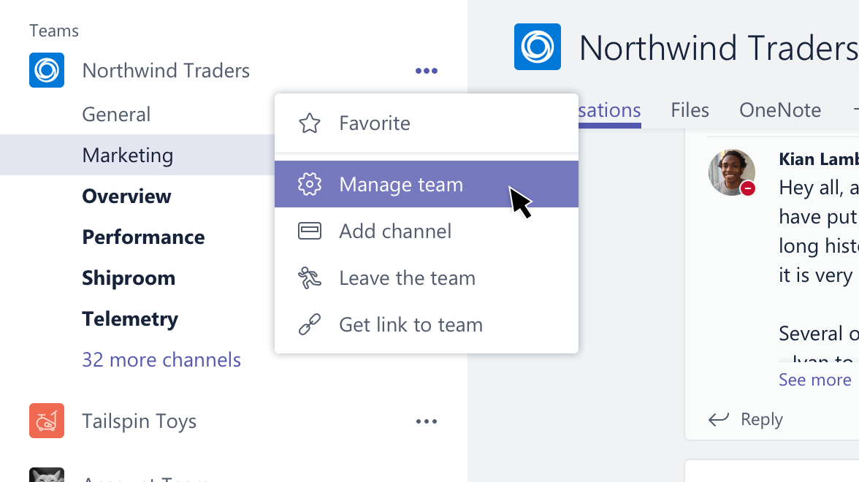

Go to the Settings tab, and then click Guest permissions. Currently, you can give guests permission to add or remove channels.

Back to top

Q: What are apps in Teams and why would I use them?
A: Apps help you find content from your favorite services and share it right in Teams. Here's how:

Chat with a bot

Bots provide answers, updates, and assistance in a channel. You can chat with them to get help with task management, scheduling, and more.

Share content on a tab

Tabs help you share content and functionality from a service in a channel. Connect to services like Excel, SharePoint, Zendesk, or a website of your choice.

Get updates from a connector

Connectors send updates and information directly to a channel. Get automatic updates from services like Twitter, RSS feeds, and GitHub.

Add rich content to your messages

These apps find content from different services and send it straight to a message. You can share things like weather reports, daily news, images, and videos with anyone you're talking to.

Get or make an app

Go to the Store to add a bot, tab, connector, or messaging app to Teams.

Back to top
Q: How do I configure an app for a team or my personal use?
A: To add and configure an app, click Store in the bottom-left corner of Teams. Once you're in the Store, browse or search to find the app you want.

Back to top

Q: How do I block a bot?
A: To stop a bot from talking, find the name of your chat with the bot in your chat list, then click More options > Mute.

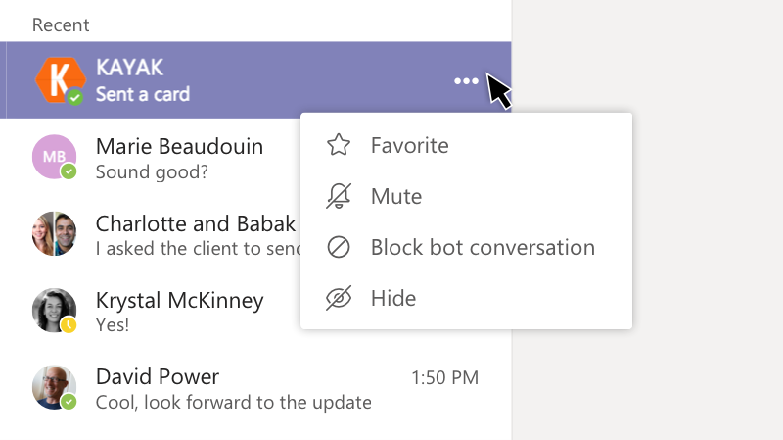

Looking for a more permanent solution?

To remove a bot from a channel entirely, find the channel name, then click More options > Manage team. On the Apps tab, click Uninstall next to the name of the bot you want to remove.

Back to top

Q: Can I use Planner in Teams?
A: Good news for fans of organization and collaboration—Teams and Planner go hand in hand!
To start using them together, add a Planner tab to Teams. Just click Add a tab next to your tabs at the top of a channel. Select Planner, then do one of the following:

- Click Create a new plan and type a name for the new Planner board.
- Click Use an existing plan and select an existing Planner board from the menu.

Back to top

Q: Can I recover a deleted team or channel?
A: Yes and yes.
To recover a deleted team, talk to your IT admin.
To recover a deleted channel, go to the team name and click More options > Manage team. Go to the Channels tab. Find the channel in the Deleted section and click Restore. All the channel conversations, files, and tabs will be restored.

Back to top

