**Kelly Rourke, MD**

Dr. Kelly Rourke is our lead physician

working at the Edwardsville WWT Family Health

Center.

*Dr. Rourke received her Bachelor of Science degree in Biology as well as her Doctor of Medicine degree from the University of Illinois.  Residency training at St John’s Mercy Medical Center (Mercy Hospital St. Louis) brought Dr. Rourke to the St. Louis area. After residency, in 1993 she remained in the St Louis area to practice medicine and raise her family. She finds her chosen career extremely rewarding and feels very fortunate to have the opportunity to positively impact the lives of her patients. Pastimes include spending time with family and friends, spoiling her dog, gardening, exercising, cycling, watching sports and enjoying nature.*

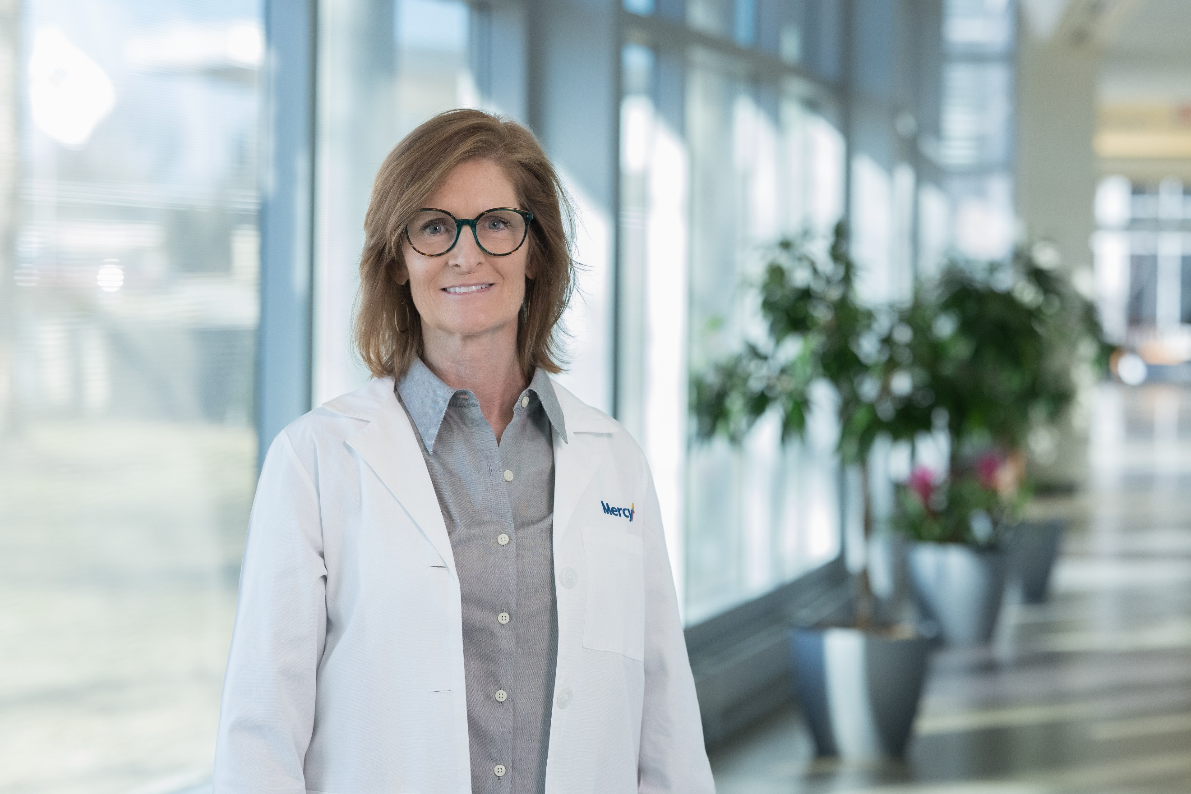

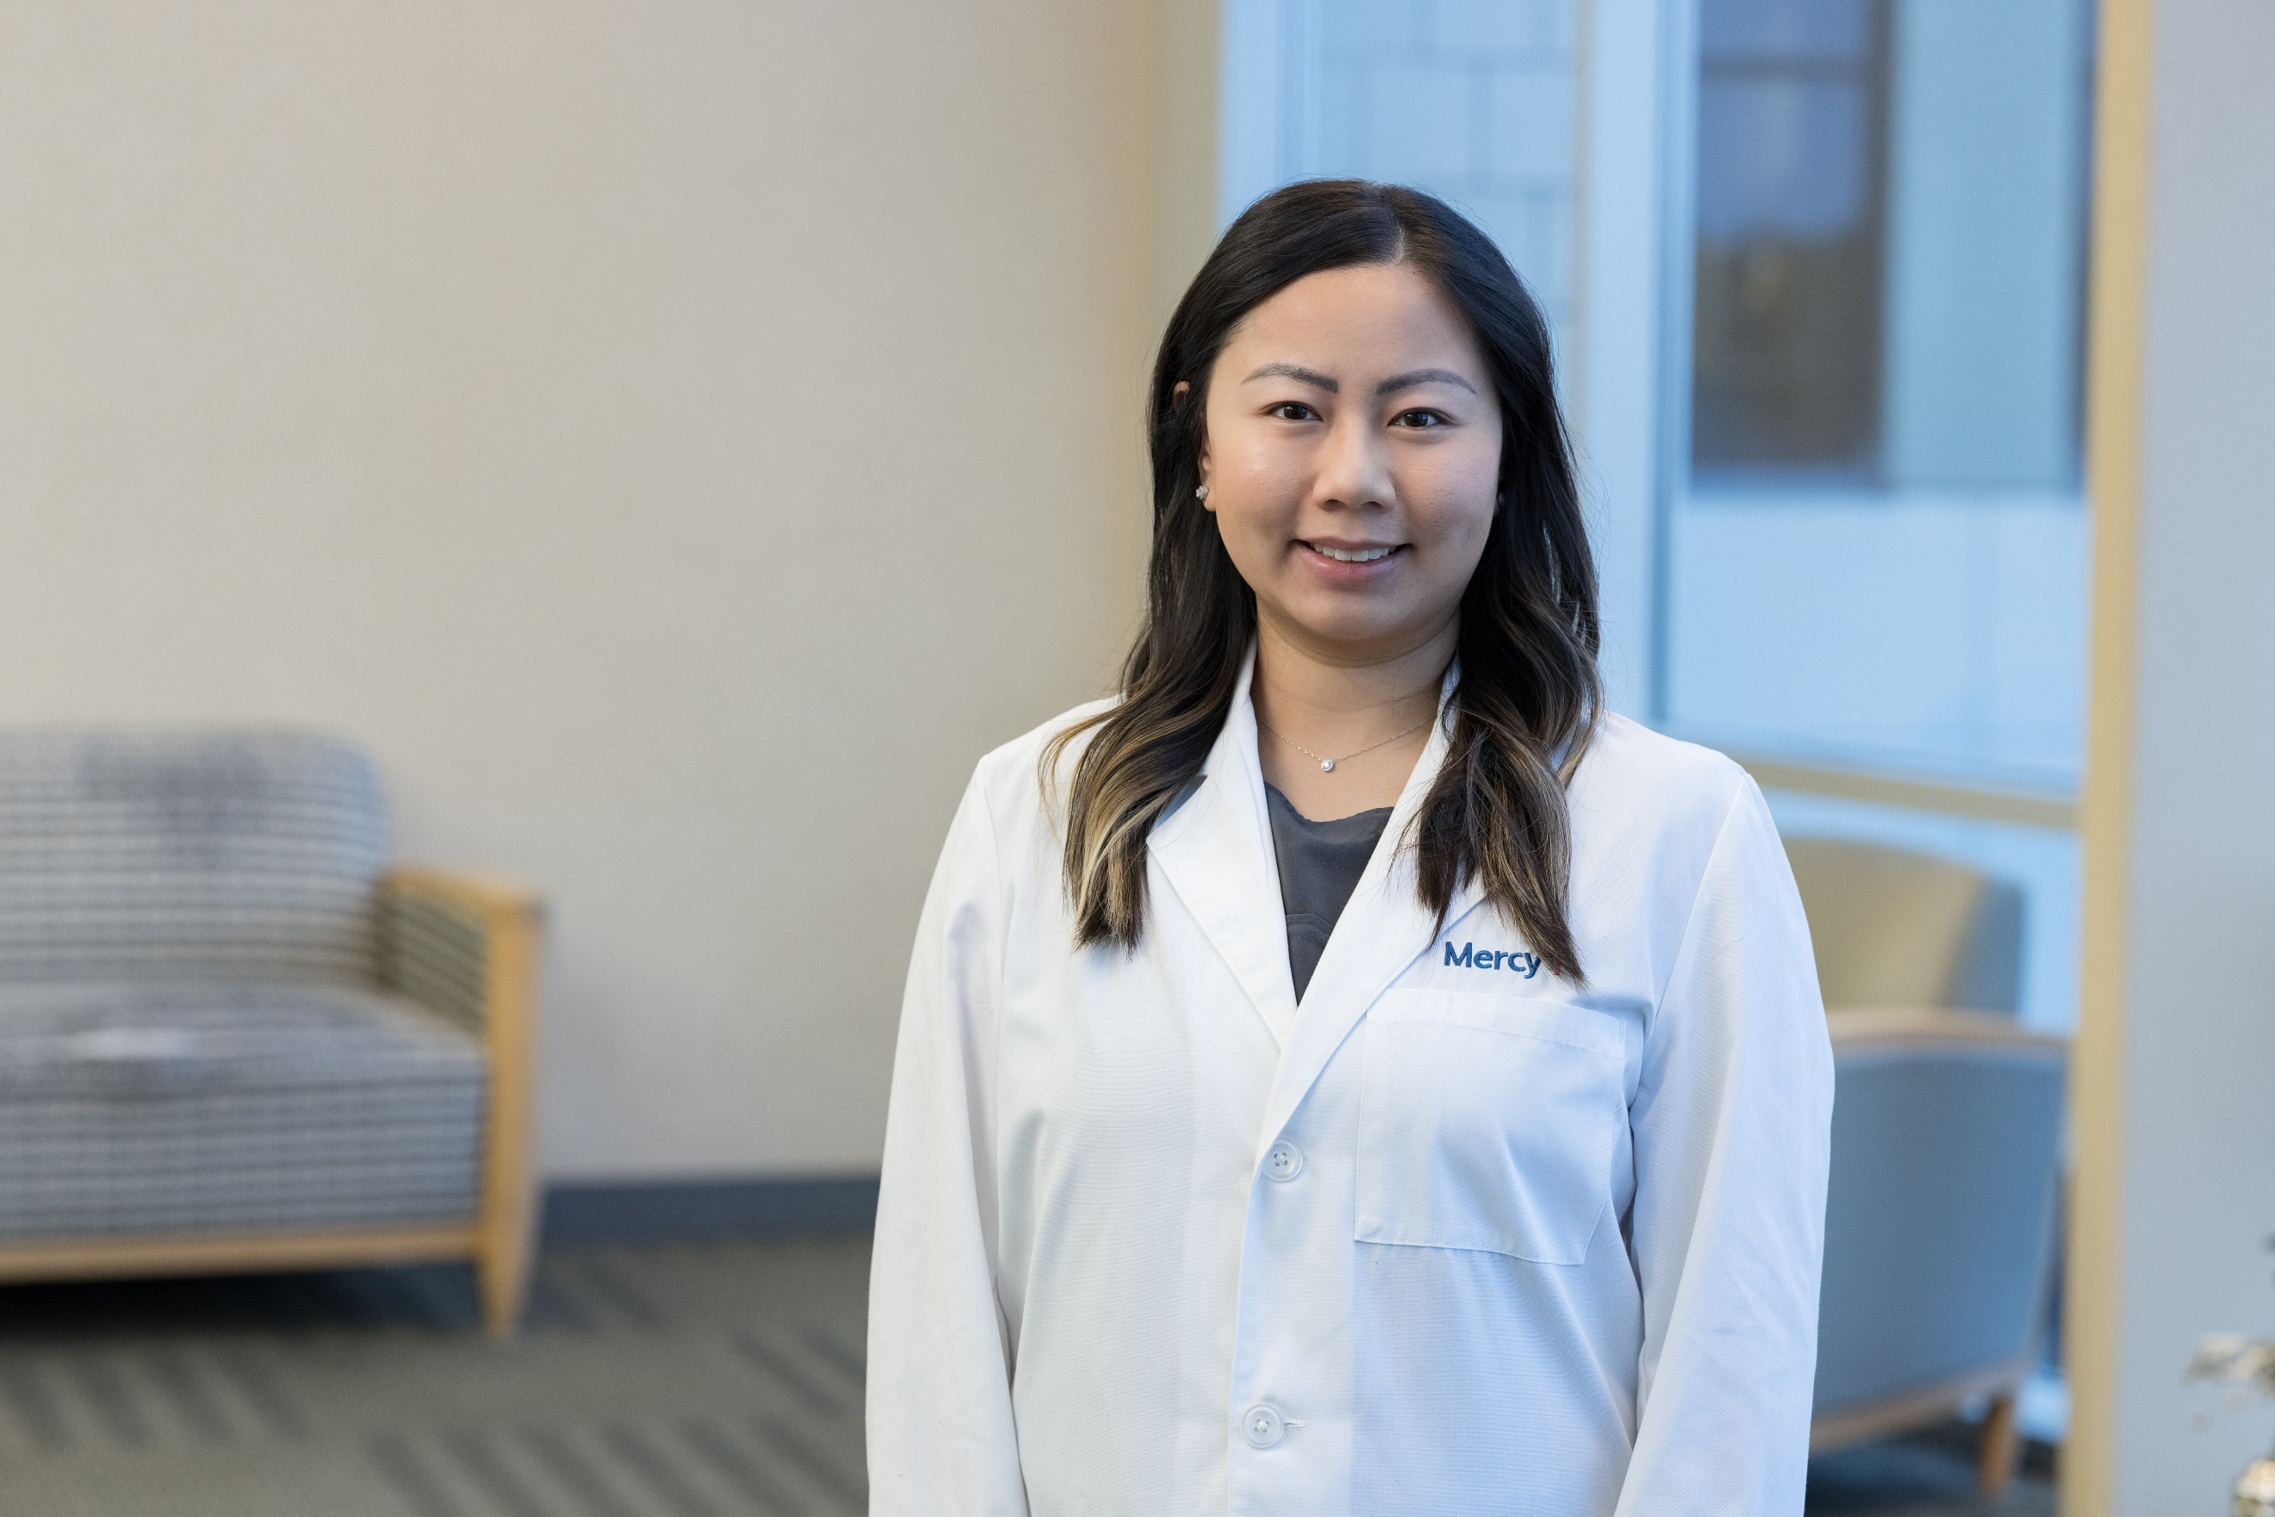

**Linda Boucher, FNP**

Linda is one of our Nurse

Practitioners working in both WWT Family

Health Centers, but her primary location is

In MO. She joined our team in 2023.

Linda received her Bachelor's of Science in Nursing from Saint Louis University, and graduated with her Master's of Science in Nursing from the University of Missouri- St. Louis with honors.  Prior to joining our team, she specialized in cardiology. Linda has a passion for providing preventive and evidence-based care. In her free time, she enjoys spending time with her husband and two children. Her interests include traveling, fitness, and exploring new foods. Linda is bilingual with proficiency in Vietnamese.

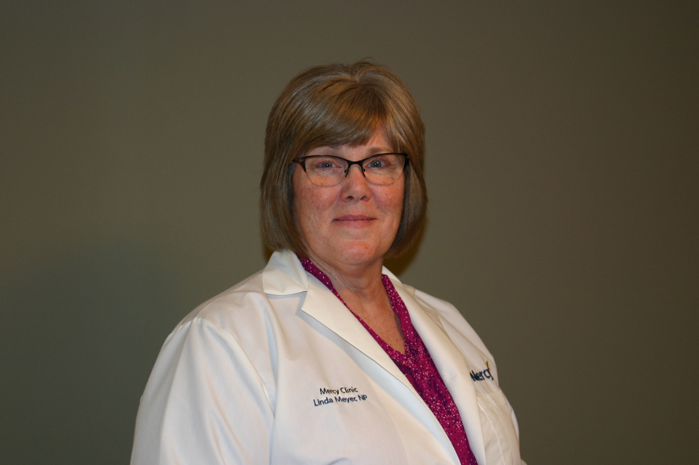

**Linda Meyer, ANP**

Linda is one of our Nurse

Practitioners working in both WWT Family

Health Centers, but her primary location is

In IL. She joined our team in 2023.

Linda received her Bachelor of Science in Nursing from Ohio State University and her Masters of Nursing degree from Kent State University. She has practiced in the St. Louis area with Mercy since 1998. Linda likes to learn about her patients’ lives and what motivates them to improve their health. She has seen great things achieved with this plan! In her time away from work, Linda enjoys spending time with her husband doing anything outdoors and watching college football.

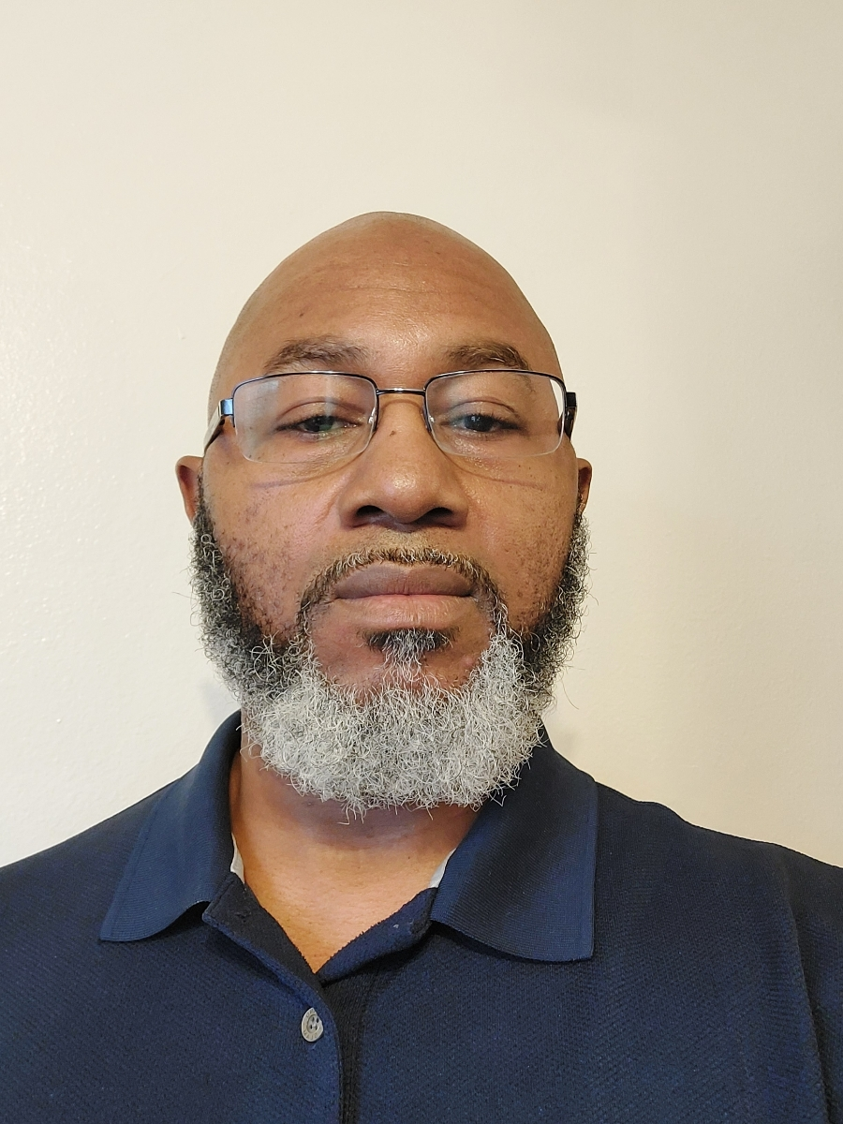

**Tim Edwards, MA, LPC**

Tim is the Behavioral Health Specialist

working in the WWT Family Health Centers.

His primary location is in IL where he will

be available in-person, but he will also be

available to MO patients virtually. Tim joined our team in 2022.

Tim works collaboratively with the medical and mental health professionals for Collaborative Care through the Mercy Clinics. He has been providing counseling since 2004. Previously, he has worked with both individual and groups in inpatient, outpatient, and virtual care settings. He has master’s degrees from Dallas Theological Seminary in Theology and Professional Counseling. Along with being an LPC in Illinois, Tim is also licensed in Texas and Missouri. He is excited for the opportunity to serve the employees and their families at WWT and working with the team at the Family Healthcare Center to provide exceptional care! When he is not working, Tim, a committed Chicago Bears fan, enjoys following professional football and basketball, reading, exercising, and spending time with family and friends.

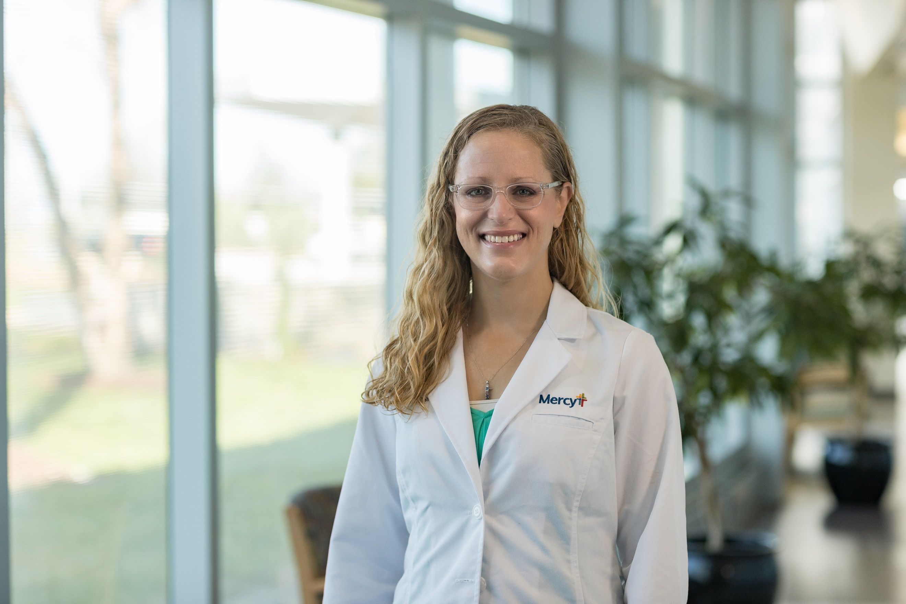

**Cynthia Poelker, MD**

Dr. Cynthia Poelker is our lead physician

working at both WWT Family Health

Centers. She was born and raised in

the St. Louis area.

Dr. Cynthia Poelker graduated from Truman State University with undergraduate degrees in Biology and Psychology.  She went on to medical school at University of Missouri - Columbia.  For residency, Dr. Poelker returned home to St. Louis to complete her family medicine residency training at Mercy Hospital.  Dr. Poelker has been practicing family medicine in the St. Louis area since 2008.  She is excited to have the privilege of joining the team at the WWTHC and looks forward to caring for the employees and their families.  Dr. Poelker is married with four children.  In her free time, she enjoys reading, exercising, traveling, and hiking.

